Lab 8

Sequence Detector, ISE 12.3 on the Digilent NEXYS2 Board

Acknowledgements:
Developed by Mr. Karl Henry at J.F. Drake State Technical College, Huntsville, Alabama. Funded by the National Science Foundation (NSF) under the ATE Program. This effort was assisted by Qunlan Cao and Craig Kief.
Lab Summary:

Sequence detection is a critical portion of all modern systems. Imagine if you when to the gas station and the machine didn’t recognize your credit card number. It does so because it is looking for a particular sequence. These sequences can be very simple or exceedingly complex. We are constantly scanning the heavens looking for the meteoroid that will destroy earth. That is done by looking for a particular series of data points and confirming that they match a predetermined sequence.

In this lab, we will implement a sequence detector on the NEXYS2 starter board. The sequence detector will look for the input series “10010.” The LED’s will show how much of the series has been detected and when the entire series has been entered an additional LED will come on. Circuit input will be controlled by a reset button, another button that sends a clock pulse and a switch that will enter a ‘1’ or a ‘0’.

The objective of this tutorial is to introduce the use of sequential logic. This sequence detector is a clocked synchronous state machine. Up to this point we have been working with combinational logic. With combinational logic the output of the circuit depends only on the current input values. In sequential logic the output depends on the current input values and also the previous inputs.

When describing the behavior of a sequential logic circuit we talk about the state of the circuit. The state of a sequential circuit is a result of all previous inputs which determines the circuit’s output and future behavior. This is why sequential circuits are often referred to as state machines.

Most sequential circuits (including our sequence detector) use a clock signal to control when the state changes. The inputs of the circuit along with the circuit’s current state provide the information to determine the circuit’s next state. The clock signal then controls the passing of this information to the state memory. The output depends only on the circuit’s state, this is known as a Moore Machine. Figure 1 on the next page shows the schematic of a Moore Machine.

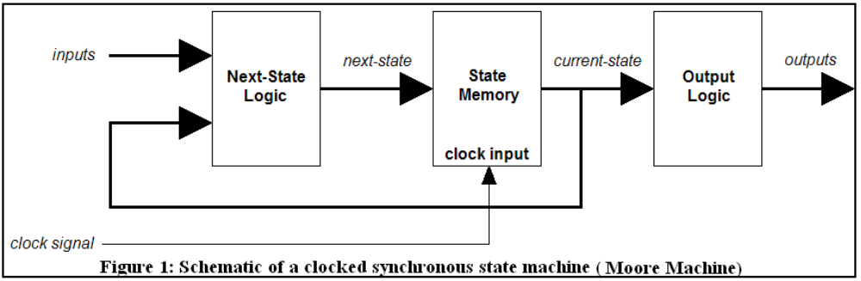

A sequential circuit’s behavior can be shown in a state diagram. The state diagram for our sequence detector is shown in figure 2. Each circle represents a state and the arrows show the transitions to the next state. Inside each circle are the state name and the value of the output. Along each arrow is the input value that corresponds to that transition.

(Note: The following state diagram illustrates the sequence detector in this tutorial.)

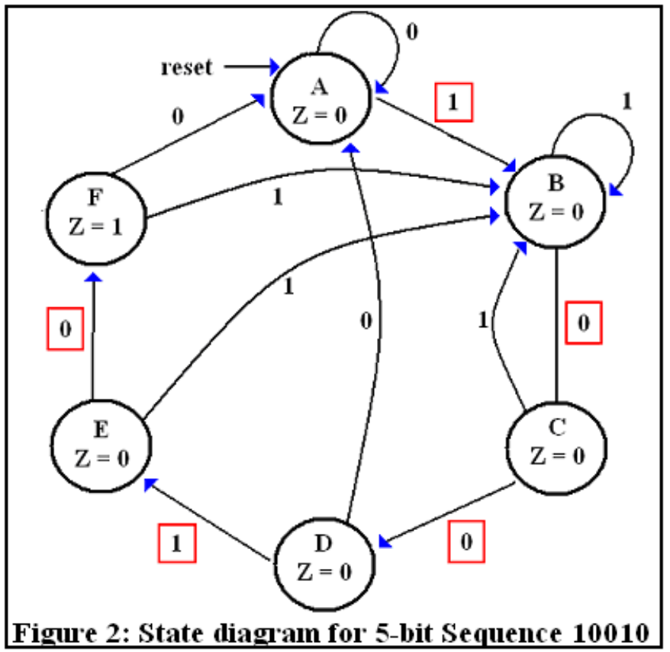

Lab Goal:

The goal of this lab is to explain some of the basics of sequential circuits as well as the process associated with sequence detection. The concept of Finite State Machines will also be investigated. In addition, it will be necessary to do a debounce circuit to allow for the button to be used as a manual clock.

Learning Objectives

- Understand the concept of “debouncing”.
- Understand the concept of sequence detection and how it is done with state machines.

Method of Evaluation: Your grade will be determined by your instructor.

Time Required: 2 hours

Lab Preparation

Read this document completely first before actually accomplishing the lab. This document was written by someone with many years of experience in this field and a great deal of effort was put into hoping to impart this knowledge to those looking to improve their skills.

Equipment and Materials

Access to Xilinx ISE software is all that is needed for this activity.

Software needed | Quantity
The following items from the Xilinx: www.xilinx.com  - free software ISE WebPACK | 1

Additional References:

Xilinx ISE 12 Software manuals found on Xilinx web site: www.xilinx.com and hardware manuals found at the Digilent Corporation’s website at www.digilentinc.com.

Lab Procedure

- Go to the wiki where you obtained this tutorial (http://vhdl_fpgas.ece.unm.edu/index.php/Main_Page) and obtain the following five files. Download the following files into a temporary folder.

        - top_sequence.vhd
        - sequence.vhd
        - sequence_tb.vhd
        - clockbuffer.vhd
        - top_sequence.ucf

- Open ISE Project Navigator. If a project is already open, go to the File menu and select Close Project. Now under the File menu select New Project. ISE will launch the New Project Wizard. In the Create New Project window under Name, enter your project name. Name it something simple, such as ‘seqdetector’. Under Project Location click the button with the three dots and navigate to where you want the project to be located. Under Top-Level Source Type, make sure ‘HDL’ is selected and then click Next.

- In the Project Settings window, copy the settings from Figure 3 and then click Next. When the Project Summary window appears, click Finish.

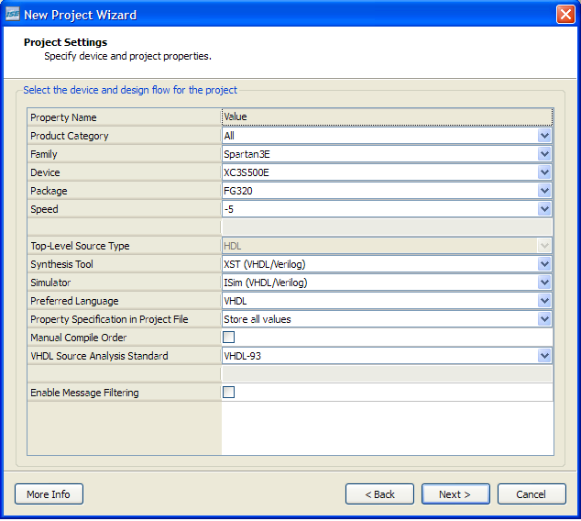

Figure 3 – Project Settings window

- Move the five files you downloaded earlier to your project folder. To the left of the Sources window, click Add Source (or right-click in the Sources window and select Add Source). Select the five files that you downloaded and click “Open”. When you get the window in Figure 4, click OK.

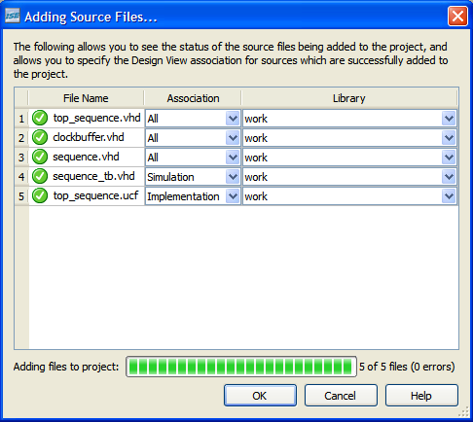

Figure 4 – Adding source files

- In the Sources window, expand the file hierarchy by clicking on the small box with the “+” symbol next to top_sequence.vhd (see Figure 5). Now open top_sequence.vhd, clockbuffer.vhd, and sequence.vhd in the ISE workspace by double clicking on the file names.

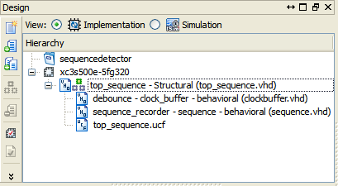

Figure 5 – Implementation file hierarchy

- At the top of the Sources window, change the view from Implementation to Simulation. Go to the pull down menu and select Behavioral. Now you can open sequence_tb.vhd in the ISE workspace (see Figure 6).

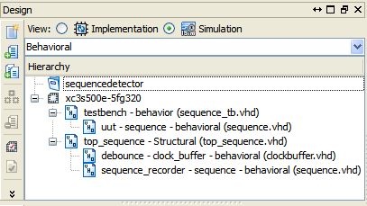

Figure 6 – Simulation file hierarchy

- Take some time to look through the .vhd files. They have been notated to help you understand the VHDL code. The layout of the three components is shown in Figure 7.

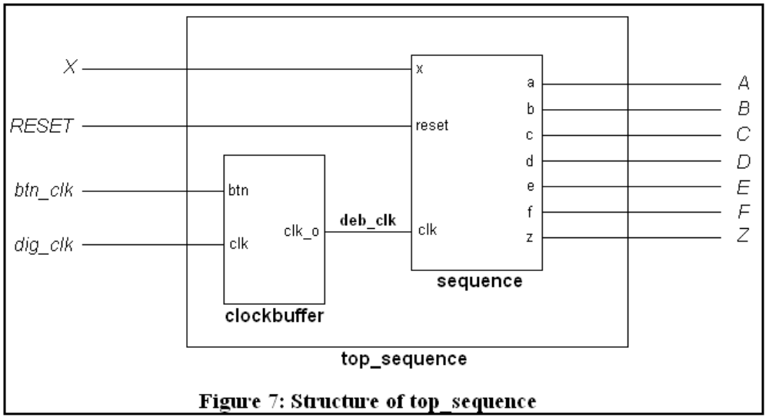

- Highlight the test bench file in the Sources window by clicking on it. In the Processes window, click on the small box with the “+” symbol next to the ISim Simulator toolbox and double click Simulate Behavioral Model to start the simulation. See Figure 8.

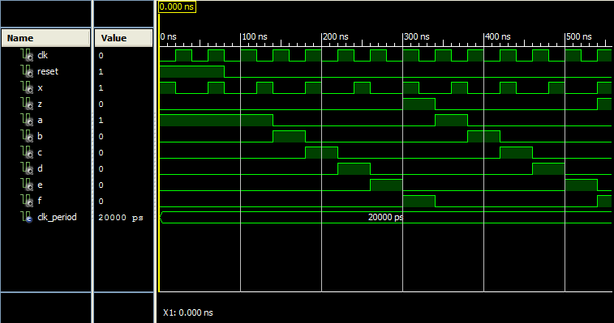

Figure 8 - Simulation

- In the Source window, change the view from Simulation back to Implementation and double click on the top_sequence.ucf file. This will open top_sequence.ucf in the ISE workspace.

- The user constraints file has been notated to show what board features have been connected to the inputs and outputs of top_sequence.vhd. See Figure 9.

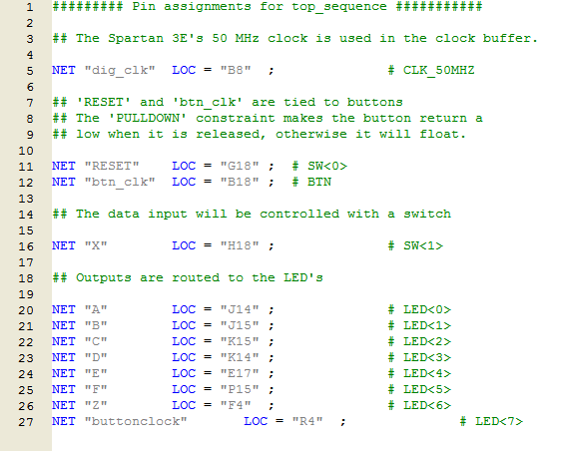

Figure 9 – User constraints file (UCF)

- It is time to program the FPGA board. In the Sources window, highlight the top_sequence.vhd file. In the Processes window, run the Synthesize – XST and Implement Design processes by double clicking on each one. As the processes finish running they will be marked with a green checkmark to indicate no problems were encountered. The Implement Design process may generate a warning (yellow triangle with an exclamation point) about excessive skew of the clock buffer output. This warning can be ignored. When both processes have finished running, double click on Generate Programming File. This process will also be marked with a green checkmark when the .bit file is successfully created. However, you can make this step easier by double clicking on Generate Programming File. This will automatically run Synthesize – XST and Implement Design. See Figure 10.

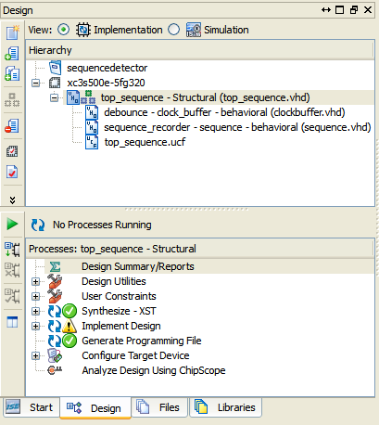

Figure 10 – Running processes

- Open Digilent Adept. After you connect the FPGA board and turn it on, the device should initialize. In the row next to FPGA, browse to top_sequence.bit, located in your project folder. A warning may appear about the startup clock for the file. Ignore this warning by clicking Yes. Click Program and the warning will appear again. Click Yes, and a green progress bar at the bottom will show the device being programmed.

- The NEXYS2 is programmed as a sequence detector for the input series “10010”, and LD0 (J14) should light up. The board will hold this program until the power is turned off, the reset button near the yellow LED is pressed, or you reprogram the board. Experiment with the board. The .ucf file shows that SW1 (H18) will be used to control the data input. A high switch enters a 1, and a low switch enters a 0. The .ucf also shows that BTN0 (B18) is a button used to control the clock. As an example, if you want to transition from state A to state B, you would flip SW1 to high and press BTN0. LD1 (J15) should light up, which indicates the transition from state A to state B. To transition to state C, flip SW1 back to low and press BTN0 again. LD2 should light up, indicating the transition. Follow this process until LD5 and LD6 light up. This means that the sequence has come “full circle”, back to the original state A.

Acknowledgment:

Wakerly, John F. (2006). Digital Design: Principles and Practices. 4th edition. New Jersey: Pearson Prentice Hall.

